DEPARTMENT OF CHEMISTRY
PROFILE
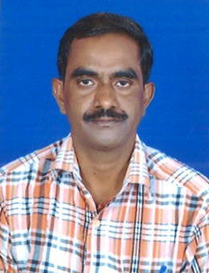
1. NAME: RAMPILLA SATYA SURYA NARAYANA
2. DESIGNATION AND : LECTURER
AND PLACE OF WORK : IDEAL COLLEGE OF ARTS AND SCIENCES (A)
KAKINADA-533003, E.G.Dt.
AP., INDIA.
3. DATE OF BIRTH: 05-08-1972
4. NATIONALITY: INDIAN
5. MOBILE NUMBER: 9247165040
6. E-MAIL:suryar5870@gmail.com
7. ADDRESS FOR COMUNICATION: R .S.S . NARAYANA
: IDEAL COLLEGE OF ARTS AND SCIENCES (A)
KAKINADA-533003
AP., INDIA.
8. DETAILS OF EDUCATIONAL QUALIFICATIONS:

S.NO | COURSE | UNIVERSITY | YEAR | SPECILIZATION
1 | MSc | ANDHRA UNIVERSITY | 2000-02 | APPLIED CHEMISTRY

9.EXPERIENCE:

S.NO | DESIGNATION | NAME OF THE COLLEGE | DATE OF JOINING | EXPERIENCE
1 | LECTURER | CHITANYA PG COLLEGE | 07-07-2004 | 2 YEARS
2 | LECTURER | RAJEEVGANDHI PG COLLEGE | 24-6-2005 | 3 YEARS
3 | LECTURER | PSN MURTHY PG COLLEGE | 02-7-2009 | 1 YEAR
4 | LECTURER | P. R GOVt PG COLLEGE | 08-07-2010 | 4 YEARS
5 | LECTURER | IDEL COLLEGE OF ARTS AND SCIENCE | 02-07-2014 | 3 YEARS

10. REGIONAL /STATE/NATIONAL LEVEL CONFERENCES/ WORK SHOPS/ SEMINARS:
A) MODERN ASPECTS OF SPECTROSCOPIC TECHNIQUES, 27-02-2016
B) MODERN ASPECTS OF ORGANIC SPECTROSCOPIC TECHNIQUES, 10-02-2017
11. ADMINISTRATIVE EXPERIENCE: NIL
12. TRAINING PROGRAMS /COURSES ATTENDED: NIL

